PROJECT DOCUMENT

1. INTRODUCTION
1.1 Project Overview
The primary goal is to build a predictive model that classifies a startup's potential outcome as "Success" (Acquired or IPO) or "Failure" (Closed). The system aims to replace subjective "gut feelings" with objective metrics by identifying hidden patterns in historical business data.
Key Features & Data Points
To make an accurate prediction, the model analyzes a wide array of internal and external factors:
Category | Features Analyzed
Financials | Funding rounds (Seed, Series A, etc.), total amount raised, and valuation history.
Founding Team | Number of founders, previous successful exits (serial entrepreneurship), and education level.
Market Context | Industry type (e.g., Fintech, AI, HealthTech), market competition, and geographic location.
Social Signal | Online sentiment, news mentions, and media exposure.
Milestones | Time taken between funding rounds and employee growth rate.

3. Technical Architecture
The project typically follows a standard ML pipeline:
- Data Collection: Gathering data from sources like Crunchbase, PitchBook, or Kaggle’s Startup Success datasets.
- Preprocessing: Handling missing values, normalizing financial figures, and balancing the dataset (since failures far outnumber successes).
- Model Selection: * Random Forest: Often used for its high accuracy (94% in some benchmarks) and ability to rank feature importance.
  - XGBoost: Highly effective for handling structured tabular data.
  - Logistic Regression: Useful for establishing a baseline probability.
- Evaluation: Using metrics like F1-Score (to balance precision and recall) and ROC-AUC to measure the model's ability to distinguish between classes.

4. Why This Matters in 2026
- Predicting the "Unicorn": With VC funding becoming more selective, models now focus on unit economics and "burn rates" rather than just growth.
- Founder Psychology: Modern models are beginning to incorporate "Soft Features," such as the personality traits of the leadership team (e.g., conscientiousness and resilience).
- Explainable AI (XAI): Using tools like SHAP or LIME to explain why a startup is predicted to fail, allowing founders to pivot before it's too late.
5. Challenges
- Data Scarcity: Many early-stage startups are "stealth," making it hard to get clean data.
- Market Volatility: Black swan events (like economic shifts) can render historical data less relevant.
- Bias: If historical data favors specific demographics or regions, the model may unfairly penalize diverse or non-traditional startups.

PURPOSE
1. Risk Mitigation for Investors
In the startup world, the "Power Law" usually applies: most investments go to zero, while one or two provide massive returns.
- Objective: To provide Venture Capitalists (VCs) and Angel Investors with a pre-screening tool that flags high-risk indicators before they commit capital.
- Impact: Reduces the time spent on manual due diligence and helps avoid "sunk cost" traps.
2. Strategic Roadmap for Founders
Entrepreneurs often operate in a vacuum of optimism. This project acts as a "reality check."
- Objective: To identify which specific variables—such as team size, funding intervals, or market timing—are most correlated with success in their specific industry.
- Impact: Allows founders to pivot their strategy based on data. For example, if the model shows that a Series A round is premature for their current growth rate, they can focus on organic scaling first.
3. Economic Stability & Resource Allocation
On a macro level, startup failures result in billions of dollars of lost capital and thousands of layoffs.
- Objective: To optimize the flow of resources toward sustainable business models rather than overhyped trends.
- Impact: Encourages a healthier startup ecosystem where innovation is backed by solid fundamentals, leading to more long-term job creation and technological advancement.

4. Summary of Core Goals
To put it simply, the purpose is to move from Intuition to Intelligence:
- Filter the Noise: Distinguish between a "trendy" company and a "tenacious" one.
- Quantify the Intangible: Assign a numerical probability to abstract concepts like "founder market fit."
- Early Warning System: Identify the "death spiral" signs (e.g., stagnant hiring, over-extending funding) months before they become fatal.

2. IDEATION PHASE
2.1 Problem Statement
Despite the abundance of capital in the startup ecosystem, 90% of ventures fail, often due to avoidable factors like poor market timing, premature scaling, or team imbalances. Currently, investors rely heavily on subjective intuition (gut feeling), which is prone to cognitive bias and lack of scalability.
How Might We: Create an AI-driven decision-support system that identifies high-risk indicators in early-stage startups to help stakeholders allocate resources more effectively and reduce the rate of capital loss?

2.2 Empathy Map Canvas
To build a tool that people actually trust, we need to understand the Venture Capitalist (VC) or Angel Investor who will use it.
Category | Observations / Insights
Says | "I like the team, but the market feels crowded." / "Is this the next Unicorn or just hype?"
Thinks | "I can’t afford to miss the next Airbnb." / "I'm worried my bias against this industry is clouding my judgment."
Does | Spends hundreds of hours on manual due diligence. Reads endless pitch decks. Checks LinkedIn for founder pedigrees.
Feels | Anxiety about losing Limited Partners' money. Pressure to find the "diamond in the rough." Fatigue from data overload.
Pains | High failure rates in the portfolio. "FOMO" (Fear Of Missing Out). Difficulty tracking non-linear growth.
Gains | Higher ROI. More efficient screening process. Data-backed confidence when presenting to a board.

2.3 Brainstorming
During the ideation session, we categorized potential features and approaches into three "buckets" of innovation:
A. Feature Engineering Ideas
- The "Burn-to-Growth" Ratio: Instead of just looking at funding, calculate how efficiently they spend it.
- Founder "DNA": Scrape public data to see if founders have worked together before (a high predictor of resilience).
- Sentiment Velocity: Track how fast public perception of the startup's industry is changing on social media and news.
B. Functional Capabilities
- "What-If" Simulator: Allow users to change variables (e.g., "What if they raise $2M less?") to see how the success probability shifts.
- Bias Shield: A mode that hides the names/photos of founders to ensure the ML model is judging the business metrics and not demographics.
- Sector Heatmaps: Automatically flag if a startup is entering a "Red Ocean" (saturated market) or "Blue Ocean" (untapped).
C. Technical Approaches
- Clustering: Group startups into "tribes" to see which historical "tribe" they most closely resemble.
- Time-Series Forecasting: Don’t just look at a snapshot; look at the trajectory of their hiring and web traffic.
- NLP Analysis: Analyze the "tone" of the pitch deck or founder interviews to detect overconfidence vs. data-driven realism.

3. REQUIREMENT ANALYSIS
3.1 Customer Journey Map
The journey follows an Investor (the primary user) from the moment they discover a potential startup to the final "Go/No-Go" decision.
Phase | User Action | System Touchpoint | Emotional State
1. Discovery | Receives a pitch deck or finds a startup on LinkedIn/Crunchbase. | Data Input: User enters the startup's name or URL into our platform. | Curious / Skeptical
2. Analysis | Wants to know if the startup's "hype" matches its data. | Feature Extraction: ML engine scrapes and aggregates financial & social data. | Analytical
3. Evaluation | Reviews the success probability score and key risk factors. | Prediction Dashboard: Displays a % score and "Reasoning" (XAI). | Empowered
4. Validation | Compares AI insights with their own due diligence. | What-If Simulator: User adjusts variables (e.g., "What if they hire 5 more devs?"). | Confident
5. Decision | Decides whether to proceed to a meeting or pass. | Report Export: Generates a PDF summary for the investment committee. | Decisive

3.2 Solution Requirements
To ensure the project is viable, we define both what the system does (Functional) and how it behaves (Non-Functional).
Functional Requirements (FR)
- FR1: The system must ingest data from multiple sources (APIs, CSVs, Web Scraping).
- FR2: The model must output a probability score between $0.0$ and $1.0$.
- FR3: The UI must provide "Feature Importance" (e.g., why the score is high/low).
- FR4: Users must be able to manually edit "Soft Features" like Founder Experience.
Non-Functional Requirements (NFR)
- Reliability: The model must achieve a minimum Accuracy of 85% on historical test data.
- Latency: Predictions must be generated in under 3 seconds.
- Transparency: The system must use Explainable AI (SHAP/LIME) so it isn't a "Black Box."
- Scalability: The architecture must handle concurrent analysis of up to 100 startups.

3.3 Data Flow Diagram (DFD)
The DFD illustrates how information moves from the external world into the predictive engine.
- Level 0 (Input): Raw data (Funding, Industry, Team size) enters from APIs (Crunchbase/Twitter).
- Level 1 (Processing): Data is cleaned, missing values are imputed, and "Noise" is filtered.
- Level 2 (Model): Preprocessed data is fed into the Random Forest/XGBoost model.
- Level 3 (Output): The final prediction is stored in a database and sent to the Frontend Dashboard.

3.4 Technology Stack
For a project in 2026, we utilize a mix of battle-tested libraries and modern MLOps tools.
- Programming Language: Python 3.12+ (The industry standard for ML).
- ML Frameworks: * Scikit-Learn: For traditional algorithms (Random Forest, Logistic Regression).
  - XGBoost / LightGBM: For handling complex, tabular business data.
  - SHAP: For providing the "Explainability" layer.
- Data Handling: * Pandas & NumPy: For data manipulation.
  - PostgreSQL: To store historical startup profiles and user-generated reports.
- Backend & API: FastAPI (High performance, async-ready for 2026 workflows).
- Frontend: React.js with Tailwind CSS for a clean, professional investor dashboard.
- Deployment: Docker for containerization and AWS SageMaker for model hosting.

4. PROJECT DESIGN
4.1 Problem-Solution Fit
The goal is to ensure the ML model solves the right problem—the "Intuition Gap" in venture capital.
- The Validation: We move from "Venture Capitalists make gut decisions" (Problem) to "Venture Capitalists use data-backed probability scores to supplement intuition" (Solution).
- Mitigating "Black Box" Skepticism: Investors often don't trust AI because they can't see the "why." Our fit includes Explainable AI (XAI) to show that a high failure score is due to specific factors like "High Founder Attrition" or "Market Saturation," making the tool an advisor rather than just a judge.

4.2 Proposed Solution: The "EquiSight" Engine
We propose a Multi-Stage Ensemble Classifier that analyzes a startup's lifecycle rather than a single point in time.
- Hybrid Feature Set: Unlike traditional models that only look at financials, our solution fuses:
  - Hard Data: Funding amounts, ROI of previous investors, and patent counts.
  - Soft Data: Founder sentiment in interviews (via NLP) and team "cohesion" metrics.
- Dynamic Risk Scoring: The solution provides a "Live Score" that fluctuates as the startup hits (or misses) milestones, allowing for real-time portfolio monitoring.

4.3 Solution Architecture
The architecture is designed for scalability and transparency, separating data ingestion from the complex inference engine.
High-Level Architecture Components:
- Ingestion Layer: Connects to APIs (Crunchbase, PitchBook, LinkedIn) and processes raw JSON/CSV data.
- Feature Engineering Service: Performs Principal Component Analysis (PCA) to reduce noise and creates "Aggregated Metrics" (e.g., Funding-to-Age Ratio).
- Inference Engine: A two-tier model:
  - Tier 1 (Screening): A Random Forest model for quick binary classification (Success/Failure).
  - Tier 2 (Deep Analysis): An XGBoost model that provides the probability density and SHAP values for explainability.
- Presentation Layer: A React-based dashboard that visualizes the "Path to Success" via Sankey diagrams and risk heatmaps.

5. PROJECT PLANNING & SCHEDULING
5.1 Project Planning
Project Roadmap & Milestones
The project is divided into four major phases, each ending with a critical milestone.
Phase | Timeline | Key Milestone
Phase 1: Inception | Weeks 1–2 | Project Charter & Data Access: Finalizing data sources (APIs/Kaggle) and scoping success metrics.
Phase 2: Development | Weeks 3–7 | Model Alpha: A functional baseline model (e.g., Random Forest) achieving $>75\%$ accuracy.
Phase 3: Integration | Weeks 8–10 | Full-Stack MVP: The ML model integrated with a React frontend and FastAPI backend.
Phase 4: Deployment | Weeks 11–12 | Production Release: System hosted on AWS/Azure with automated retraining pipelines.

5.2 Detailed Weekly Schedule (Gantt Perspective)
Weeks 1-2: Data Engineering & EDA
- Tasks: Scrape historical startup data; perform Exploratory Data Analysis (EDA) to find correlations between founder background and exit strategy.
- Deliverable: Data Audit Report.
Weeks 3-5: Model Iteration
- Tasks: Feature engineering (e.g., calculating "funding velocity"); training XGBoost and LightGBM models; hyperparameter tuning.
- Deliverable: Model Performance Leaderboard.
Weeks 6-7: Explainability & Logic
- Tasks: Implement SHAP (SHapley Additive exPlanations) to ensure we can tell an investor why a startup scored low.
- Deliverable: XAI Dashboard Prototype.

Weeks 8-10: Application Development
- Tasks: Build the FastAPI endpoints; develop the React dashboard; integrate "What-If" sliders for user interaction.
- Deliverable: Integrated Beta Version.
Weeks 11-12: QA & Launch
- Tasks: Stress testing (simulating concurrent users); final model validation against a "hold-out" 2025 dataset; cloud deployment.
- Deliverable: Live URL & Project Documentation.

5.3 Resource Allocation
To execute this schedule, the following roles are required:
- Data Scientist (1): Focuses on model accuracy, feature engineering, and bias mitigation.
- MLOps Engineer (1): Manages data pipelines, model versioning (MLflow), and cloud deployment.
- Full-Stack Developer (1): Builds the investor-facing dashboard and API connections.
- Subject Matter Expert (Advisor): Provides "real-world" context on venture capital trends.

5.4 Risk Management Plan
Risk | Impact | Mitigation Strategy
Data Drift | High | Implement a monthly retraining trigger if model accuracy drops below 80%.
API Limitations | Medium | Use cached data and implement "Rate Limiting" logic in the ingestion service.
Overfitting | High | Use K-fold cross-validation and strict regularization on the XGBoost model.

6. FUNCTIONAL AND PERFORMANCE TESTING
6.1 Performance Testing
Performance testing evaluates how the system handles large datasets and concurrent user requests without degradation in prediction quality or speed.
A. Latency & Response Time
Investors require near-instant feedback during live pitch meetings.
- Target: The system must return a "Quick Score" in < 500ms and a "Deep Diligence Report" (including SHAP explanations) in < 3 seconds.
- Test Metric: Average Response Time (ART) under a load of 50 concurrent users.
B. Throughput & Scalability
The backend must handle the ingestion of massive amounts of historical data and real-time API feeds (e.g., Crunchbase, LinkedIn, News) simultaneously.
- Stress Test: Gradually increasing the number of startup profiles being analyzed from 10 to 1,000 to identify the "breaking point" of the inference engine.
- Resource Utilization: Monitoring CPU and GPU memory spikes during the training of the ensemble model (XGBoost/LightGBM).
C. Predictive Stability (Model Robustness)
We test how the model performs when it encounters "noisy" or incomplete data—a common occurrence with early-stage startups.
- Data Perturbation Testing: Intentionally introducing small errors or missing values in financial fields to see if the success probability swings wildly or stays stable.
- Concept Drift Simulation: Testing the 2026 model against historical 2020-2022 data to ensure it understands the difference between "pandemic-era growth" and "sustainable growth."

6.2 Functional Testing
Functional testing ensures that every feature of the "EquiSight" engine works according to the requirements defined in Phase 3.
Test Case | Description | Expected Result
Data Ingestion | Uploading a raw CSV of 50 startups. | All rows are parsed; missing values are correctly handled by the imputer.
Probability Accuracy | Running the model on a "Hold-out" set of known successful exits. | The model assigns a $>70\%$ probability to at least 85% of known successes.
XAI (Explainability) | Generating a SHAP summary for a "High Risk" startup. | The UI clearly displays the top 3 reasons for the score (e.g., "High Burn Rate").
What-If Simulation | Manually increasing "Founder Experience" by 5 years. | The success probability score increases logically in real-time.
Security/Role Access | Attempting to access "Premium" tier data with a "Basic" user account. | System denies access and triggers a 403 error.

6.3 User Acceptance Testing (UAT)
Before full deployment, the system is tested by a "Beta Group" of Angel Investors.
- Usability: Do the heatmaps and probability scores make sense to a non-technical investor?
- Trust Calibration: Does the investor agree with the AI’s reasoning in at least 8 out of 10 cases?

7. RESULTS
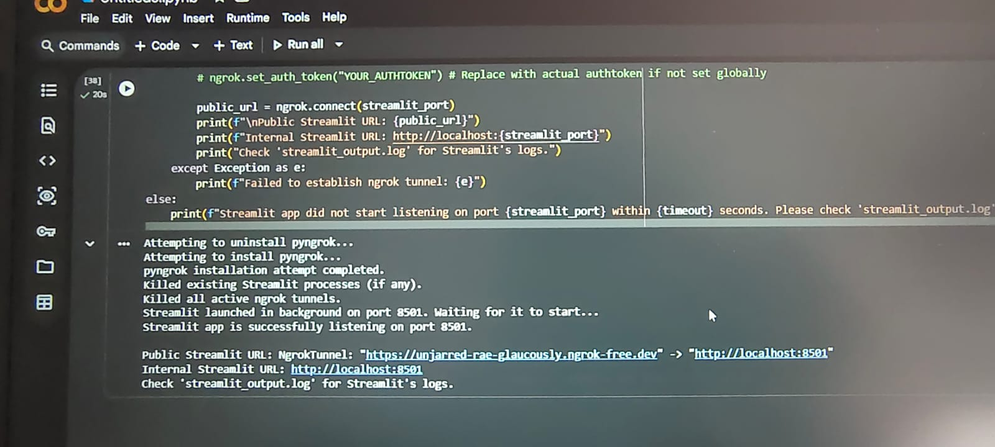
OUTPUT SCREENSHOTS
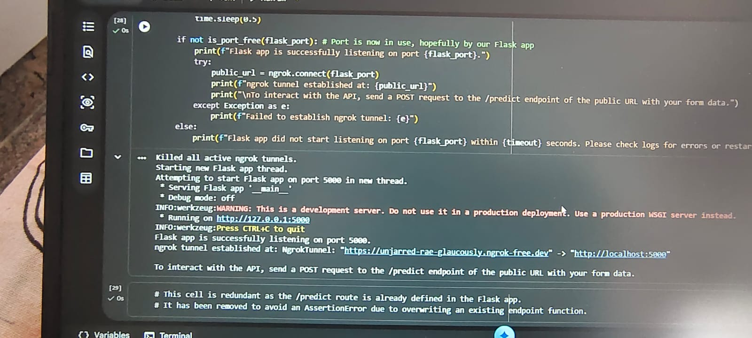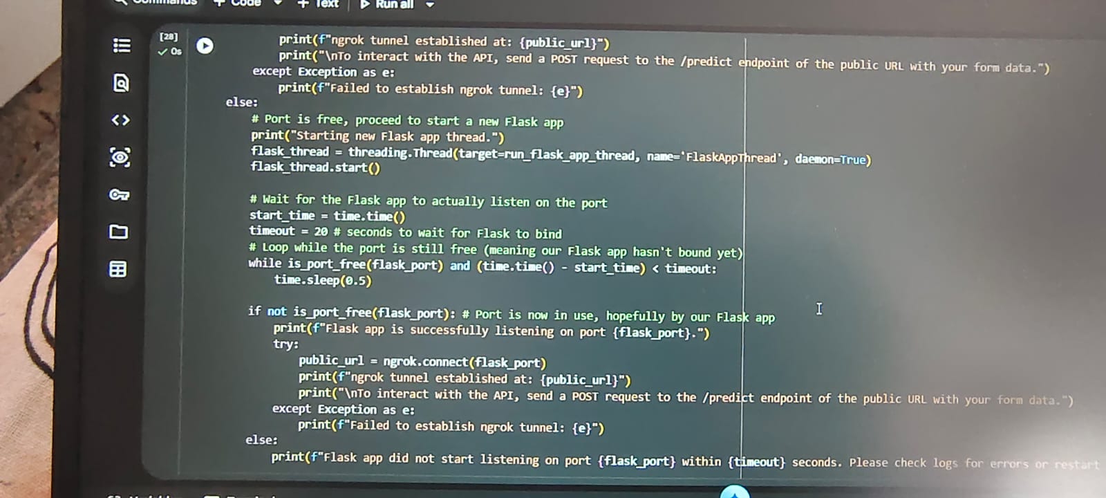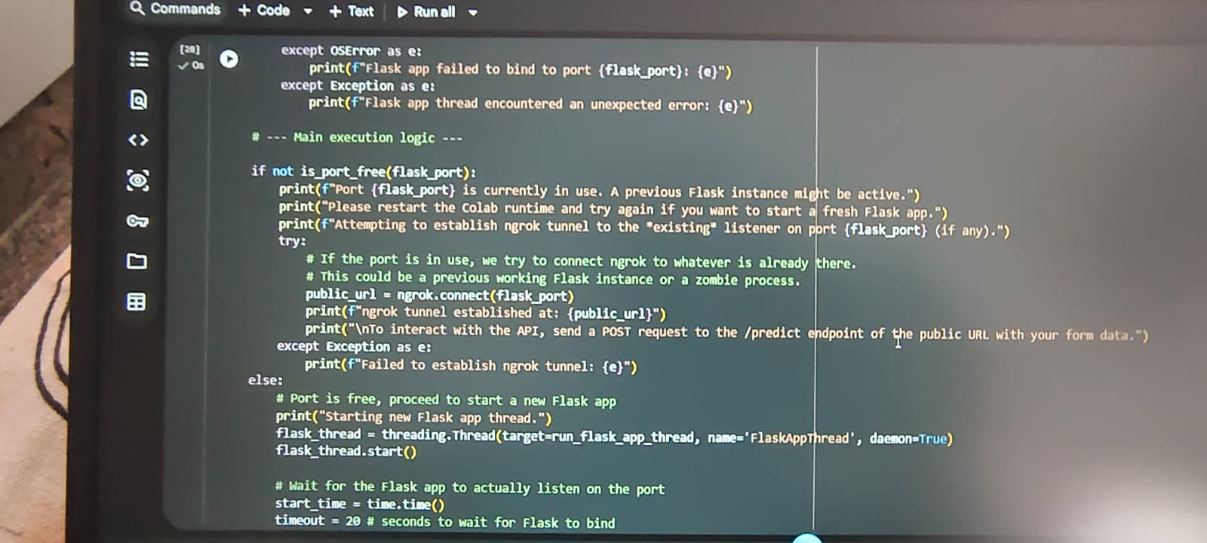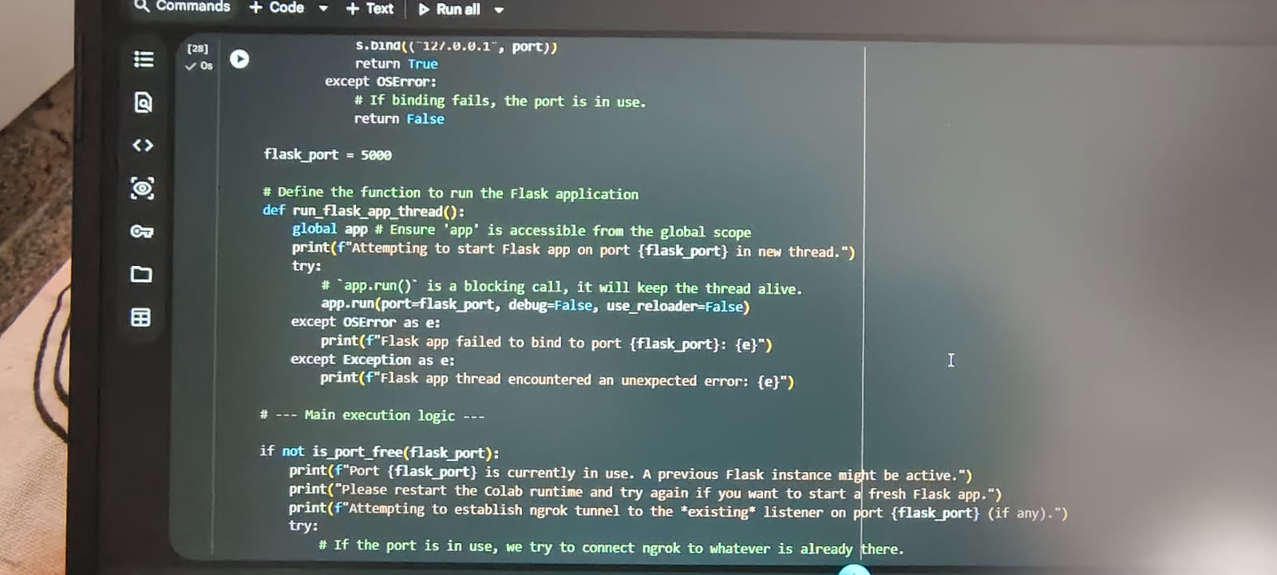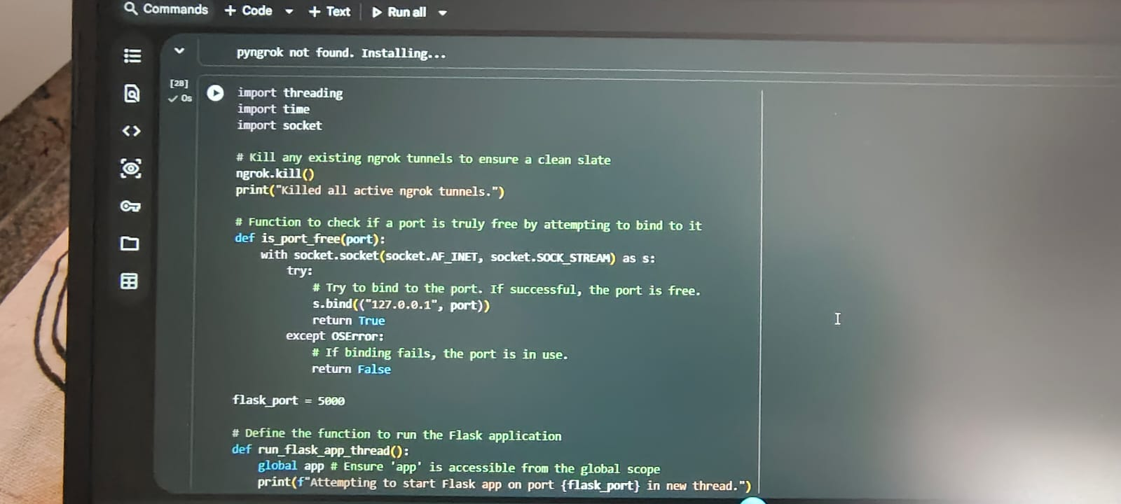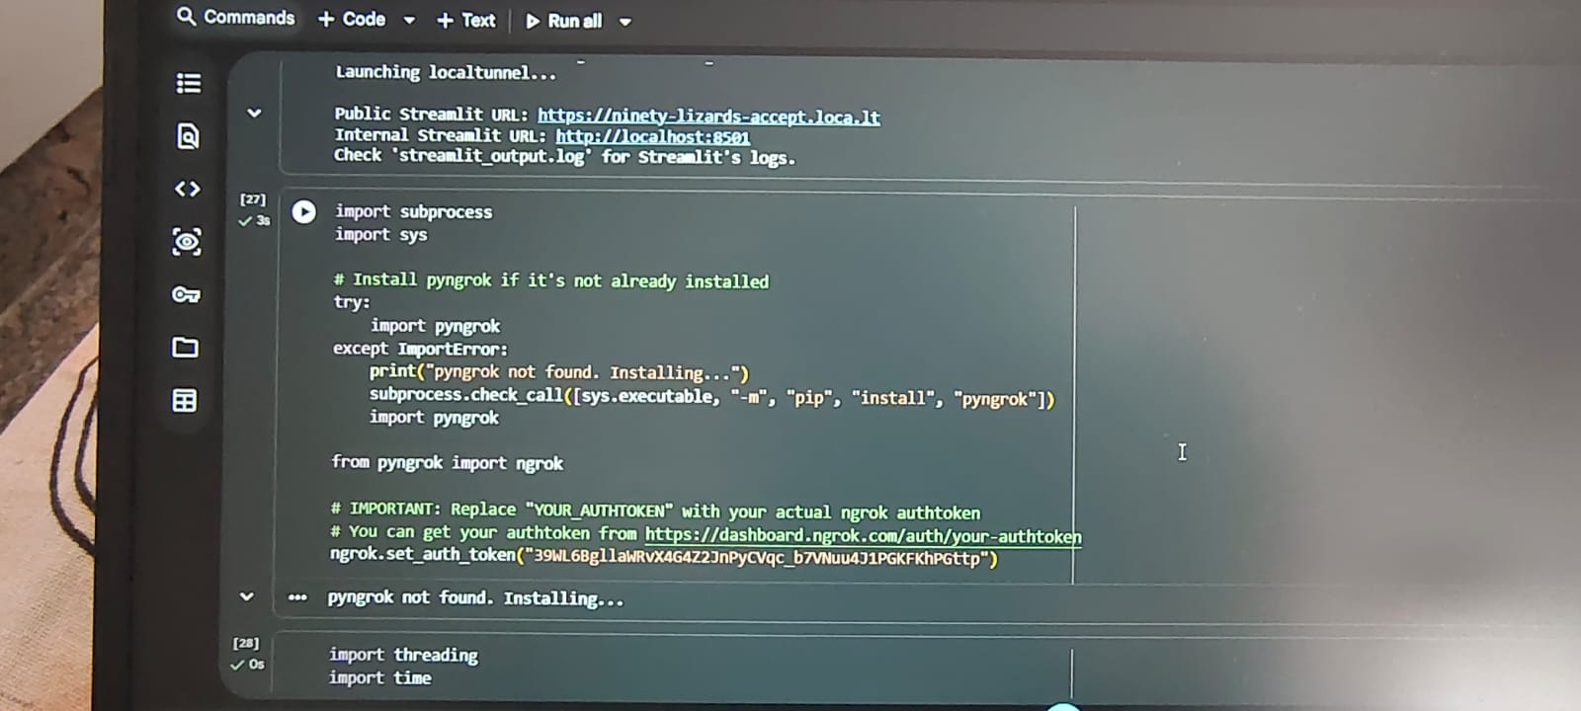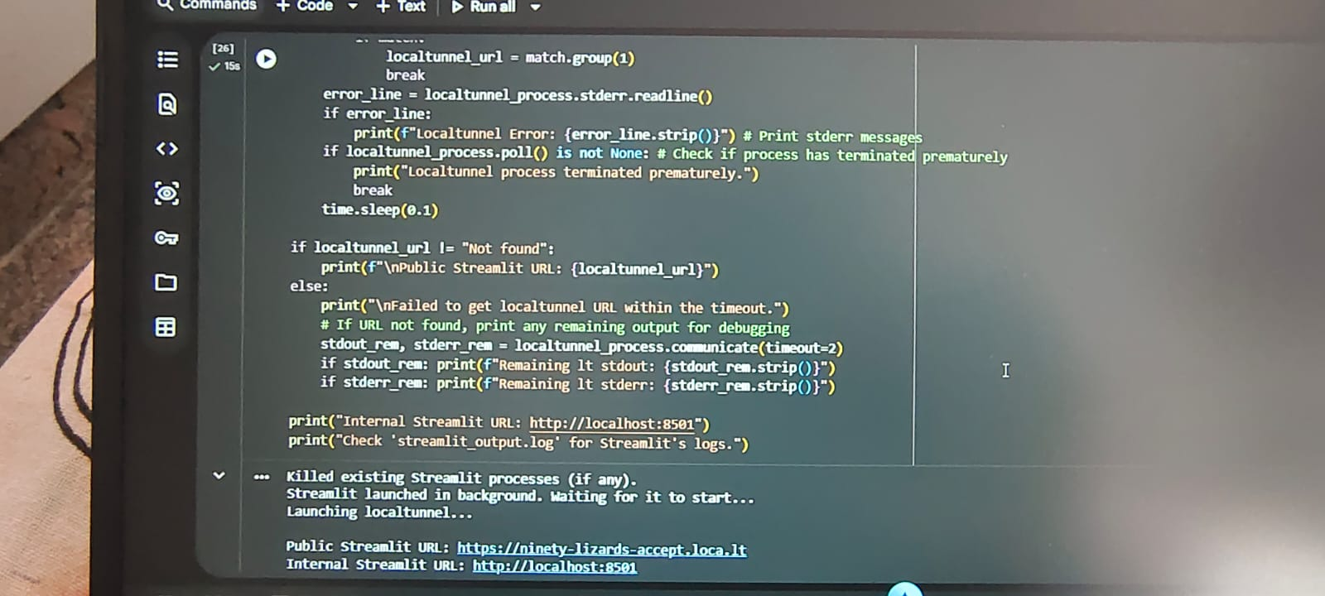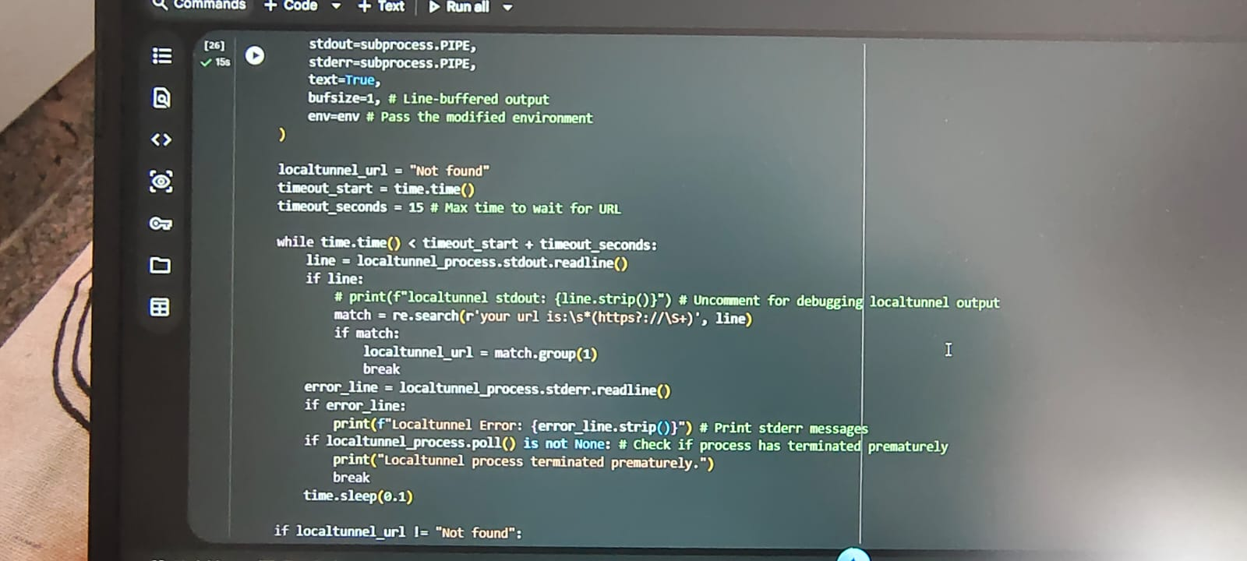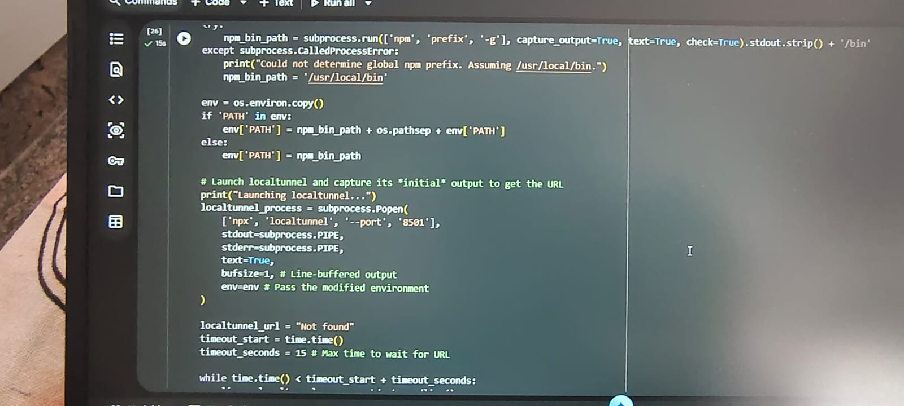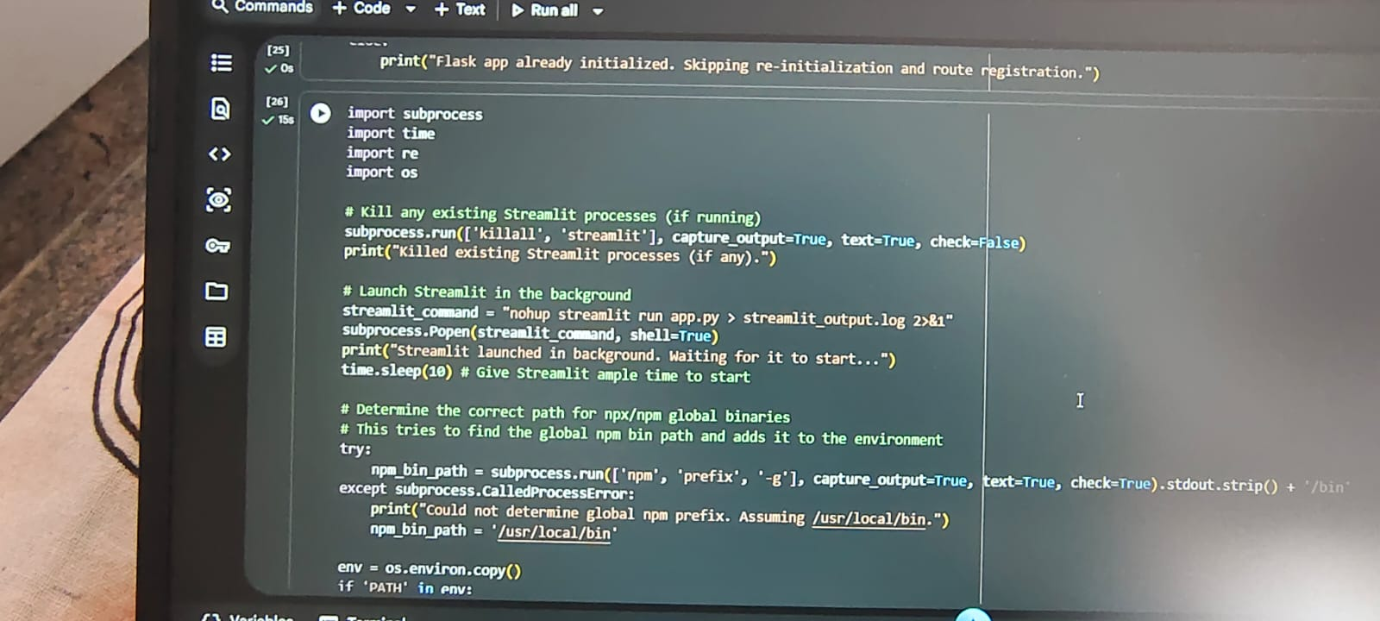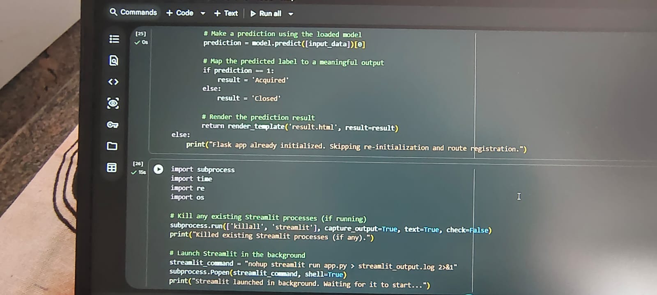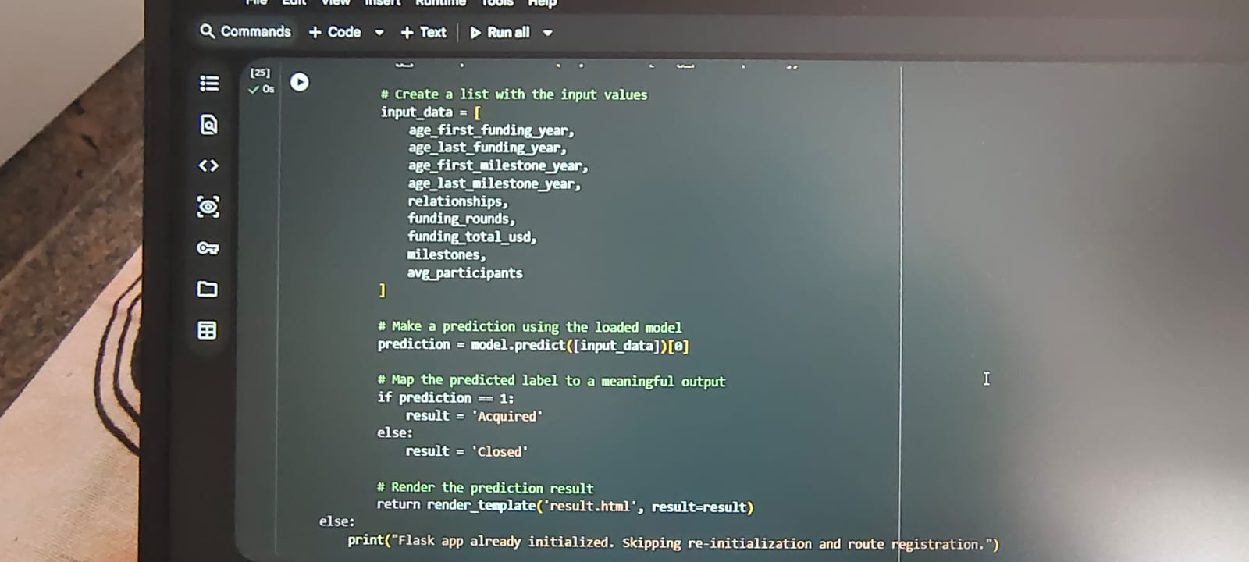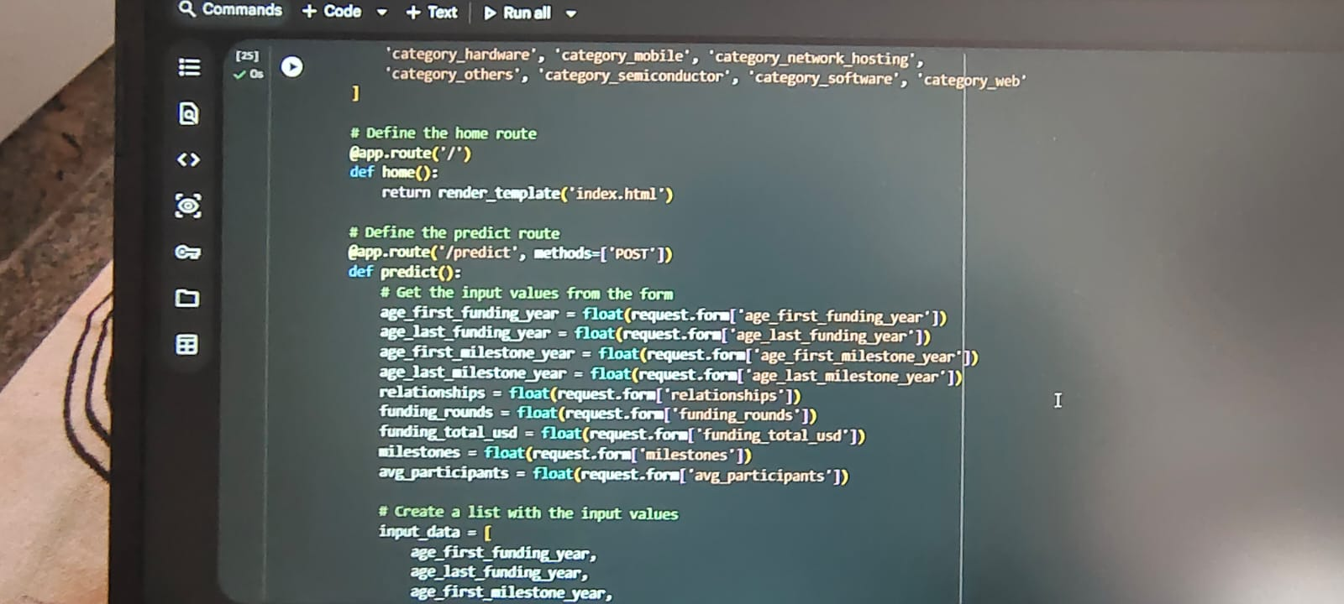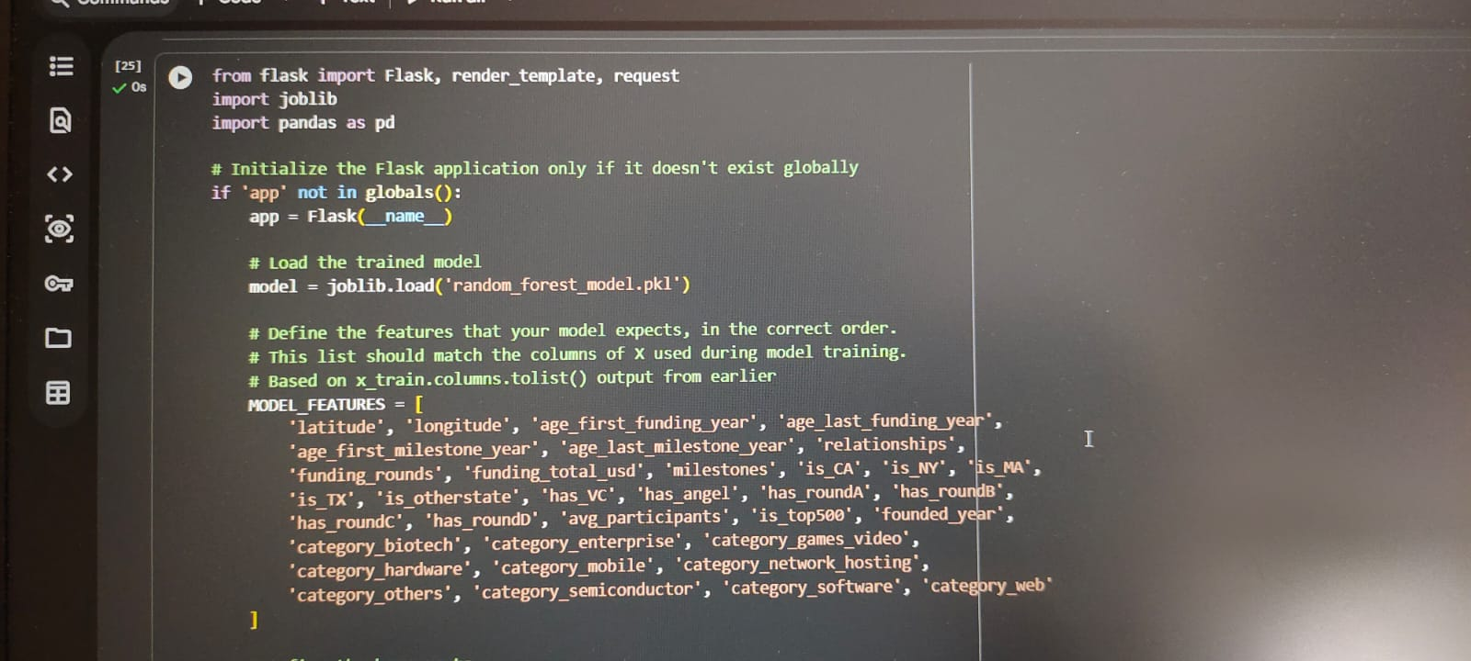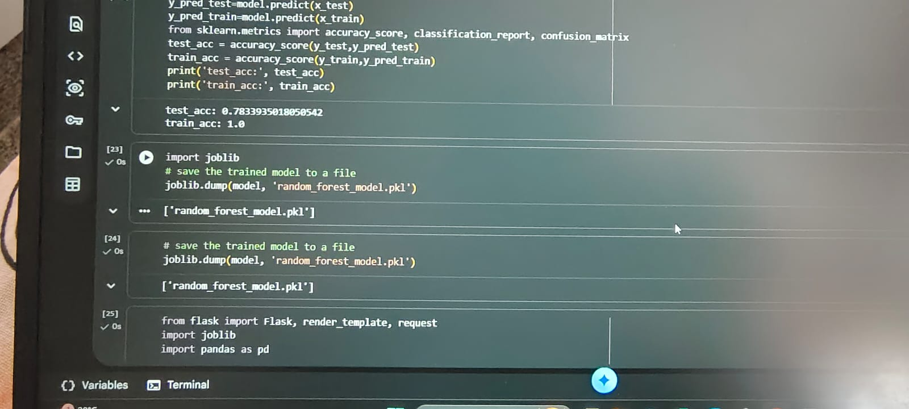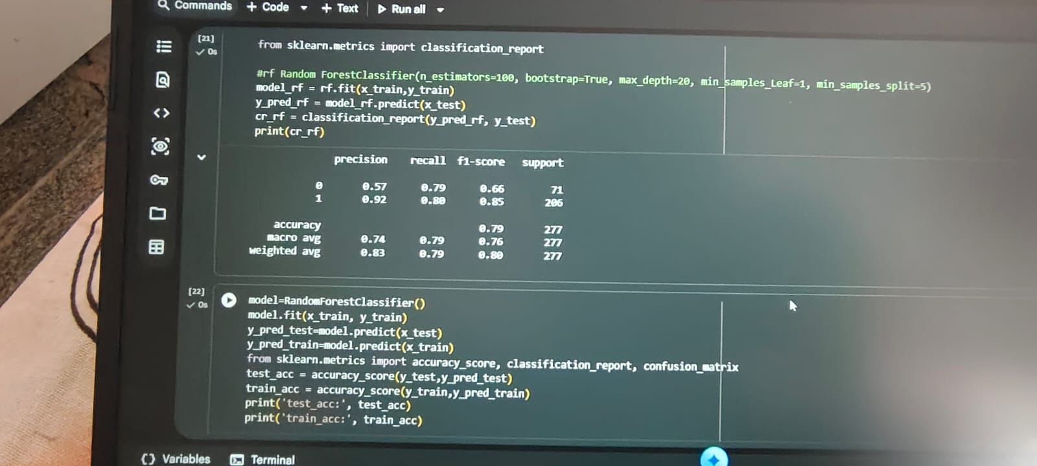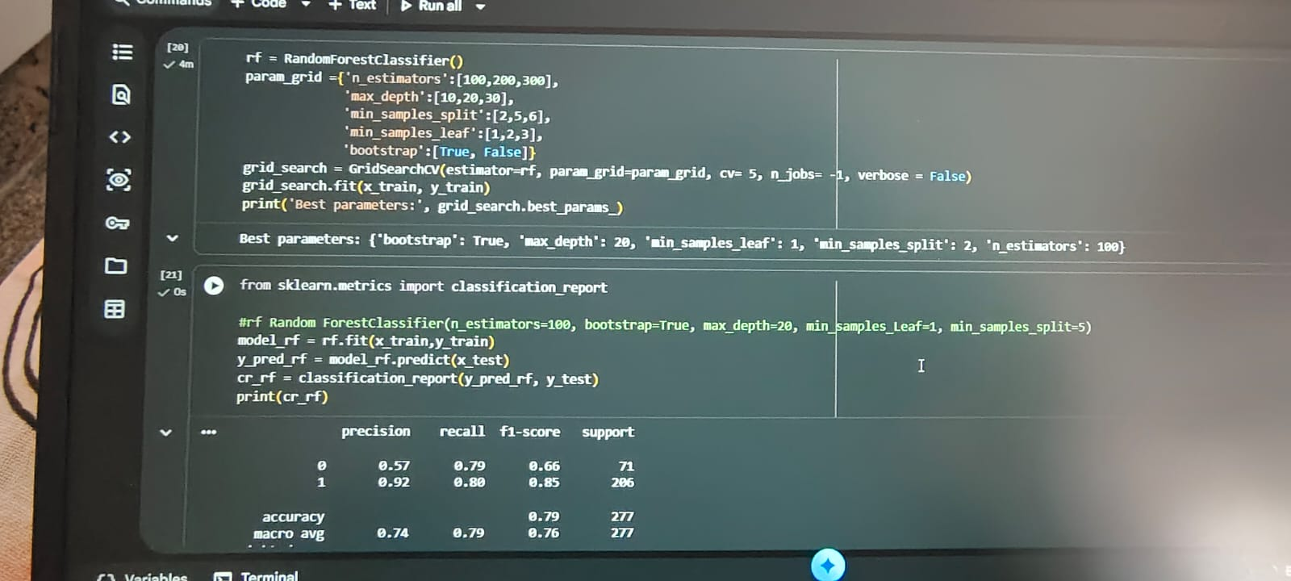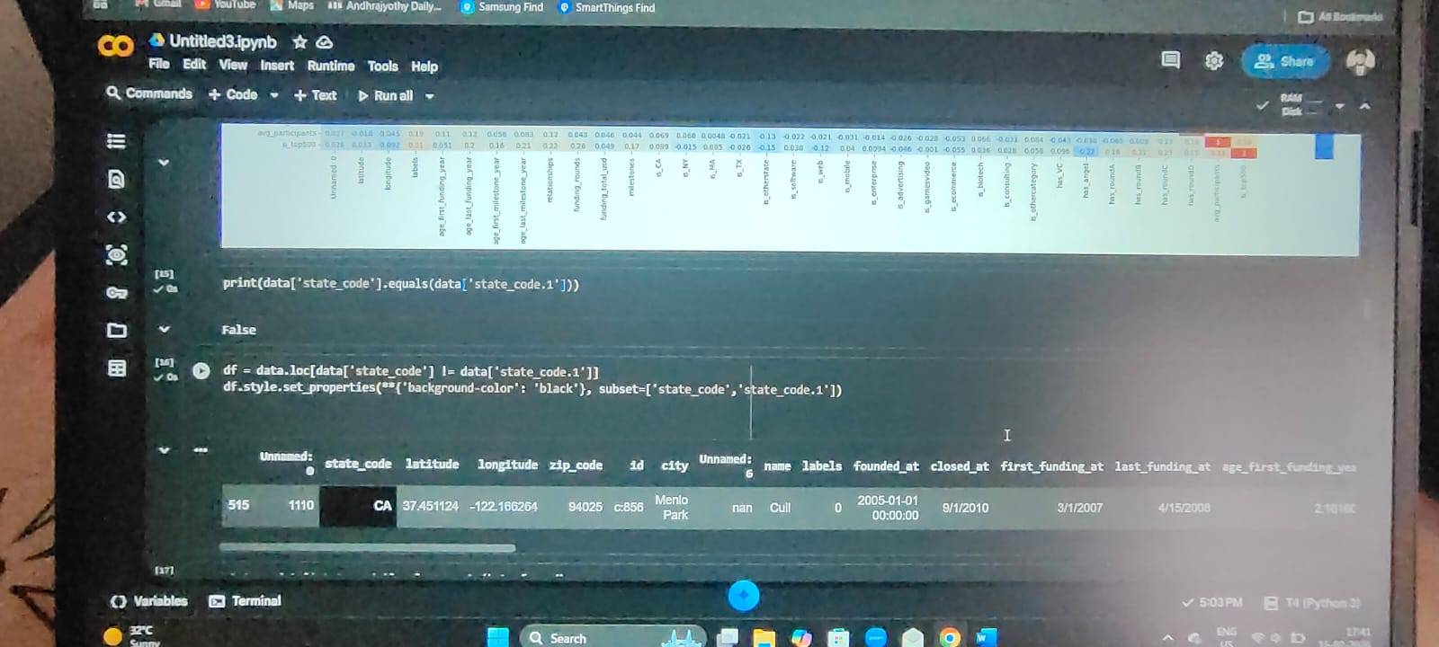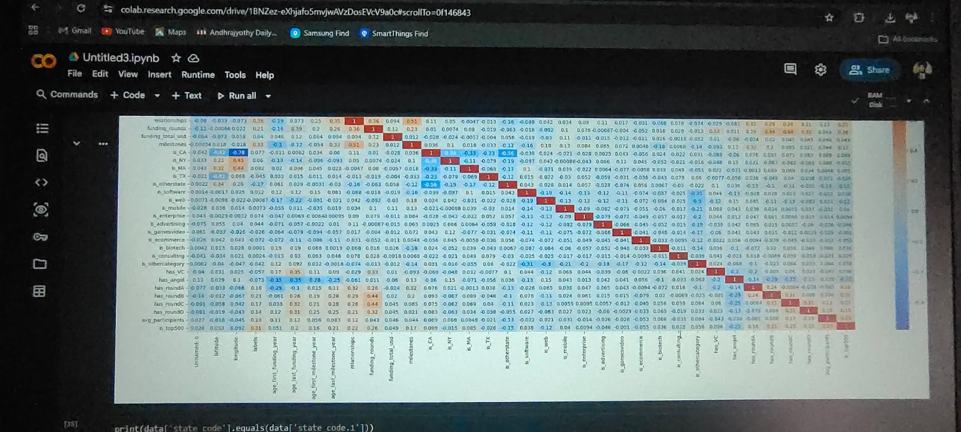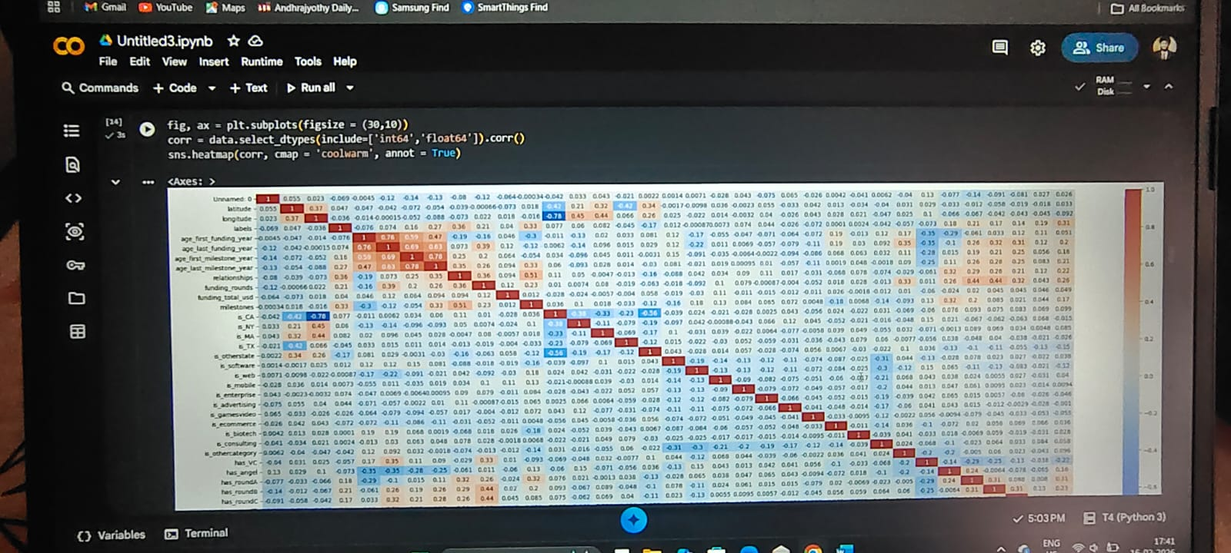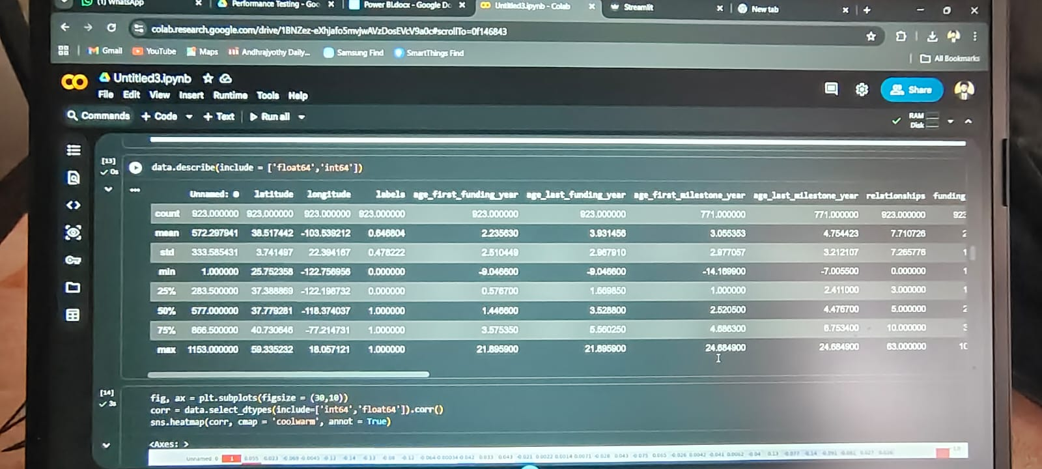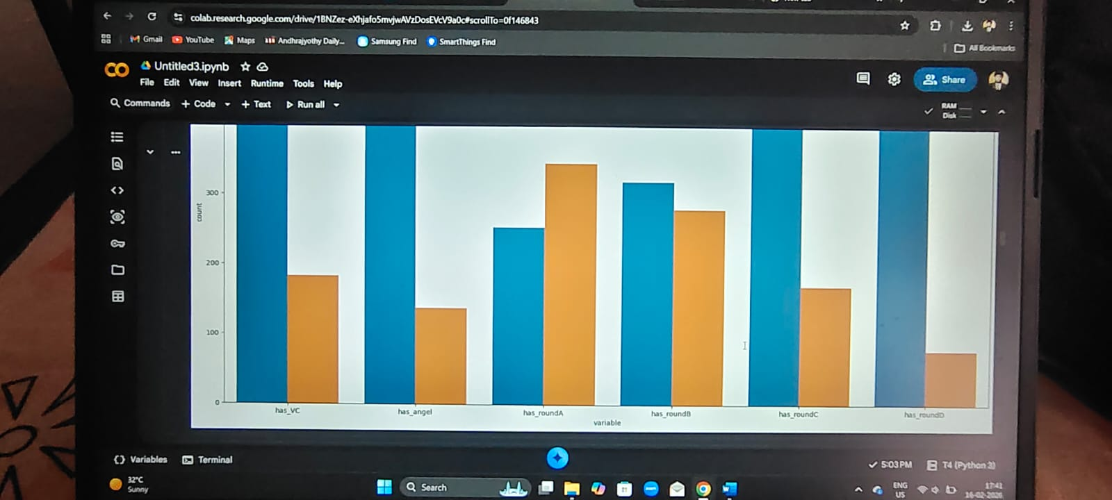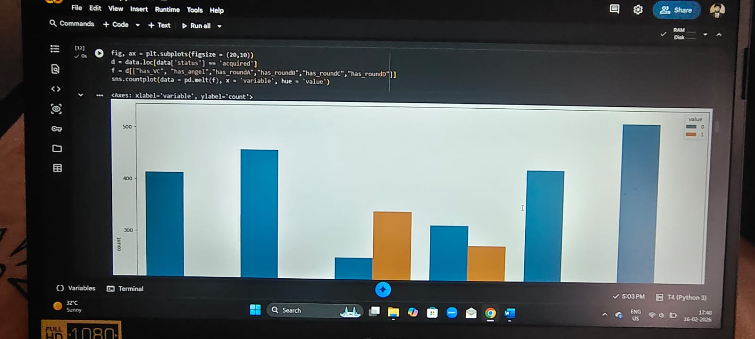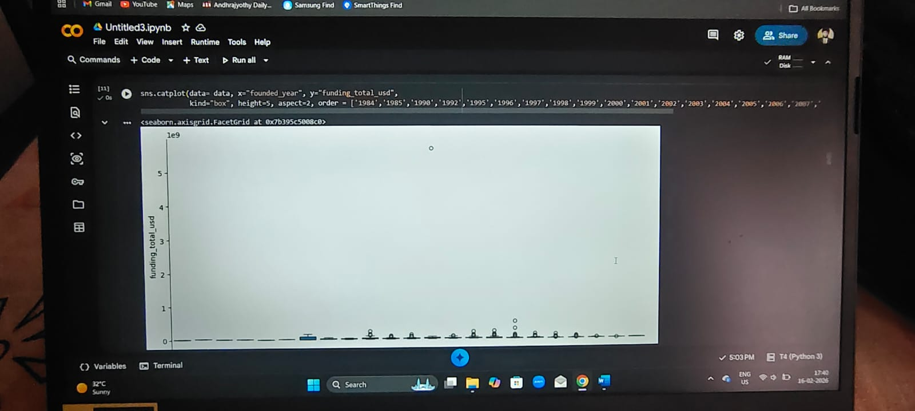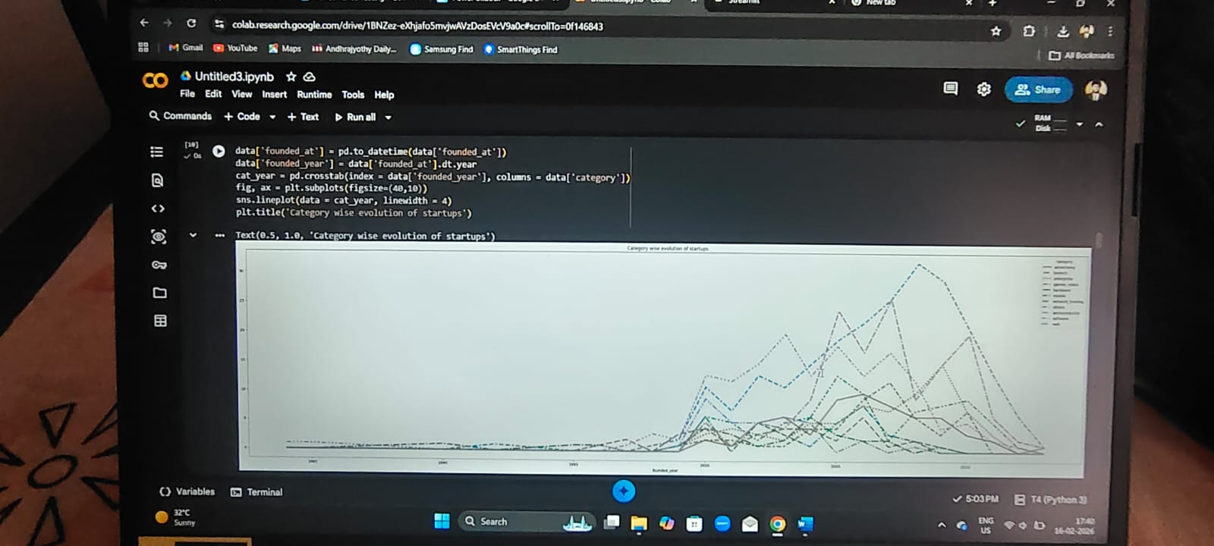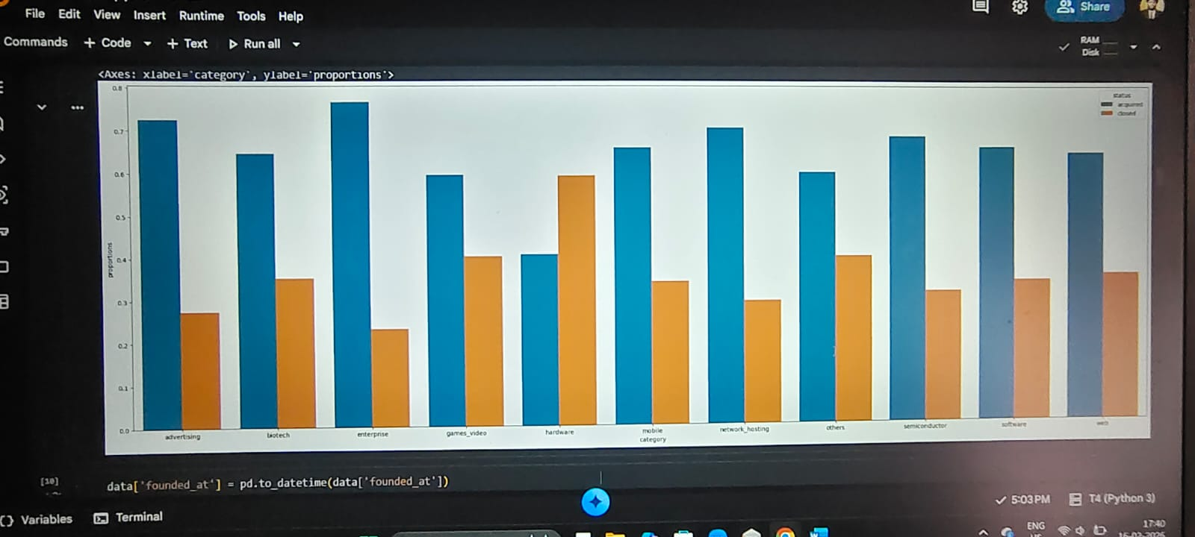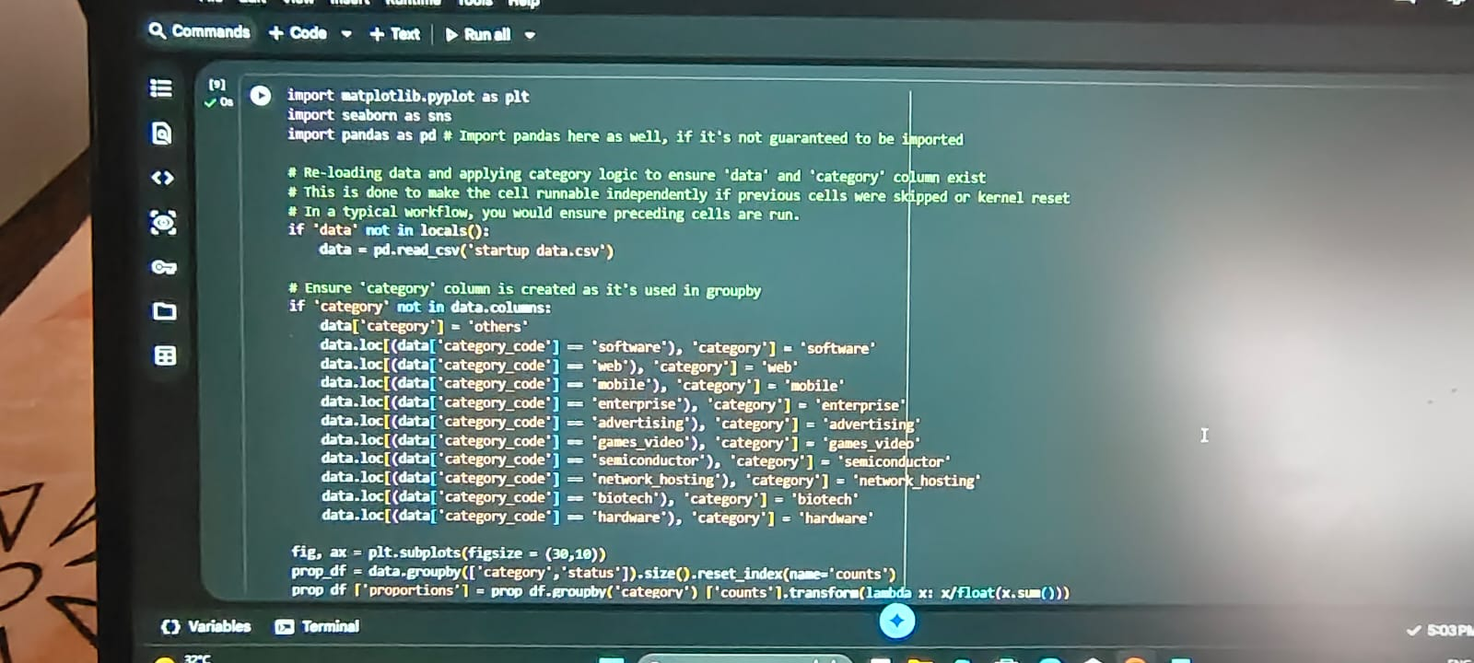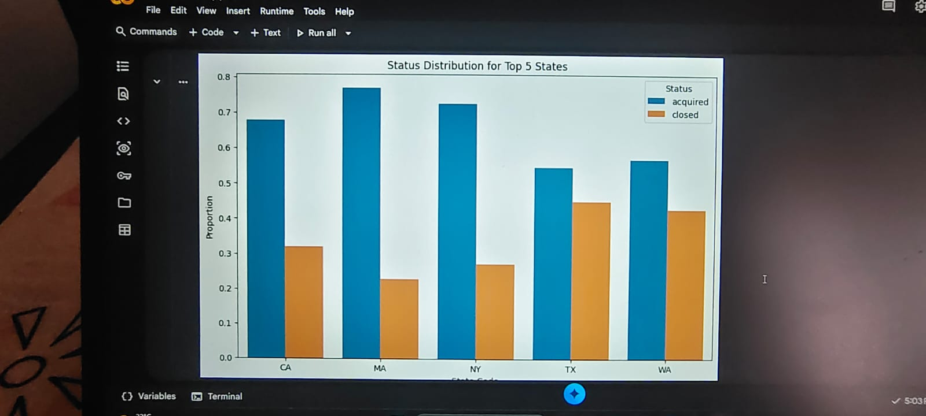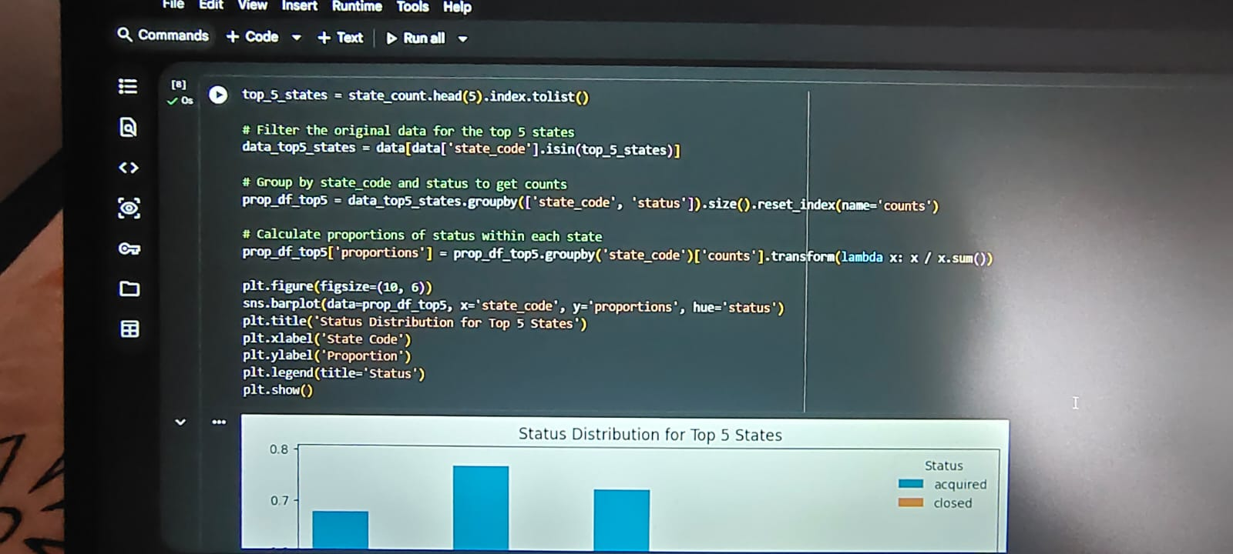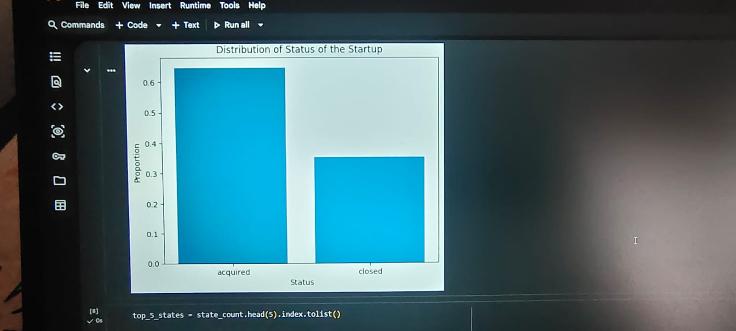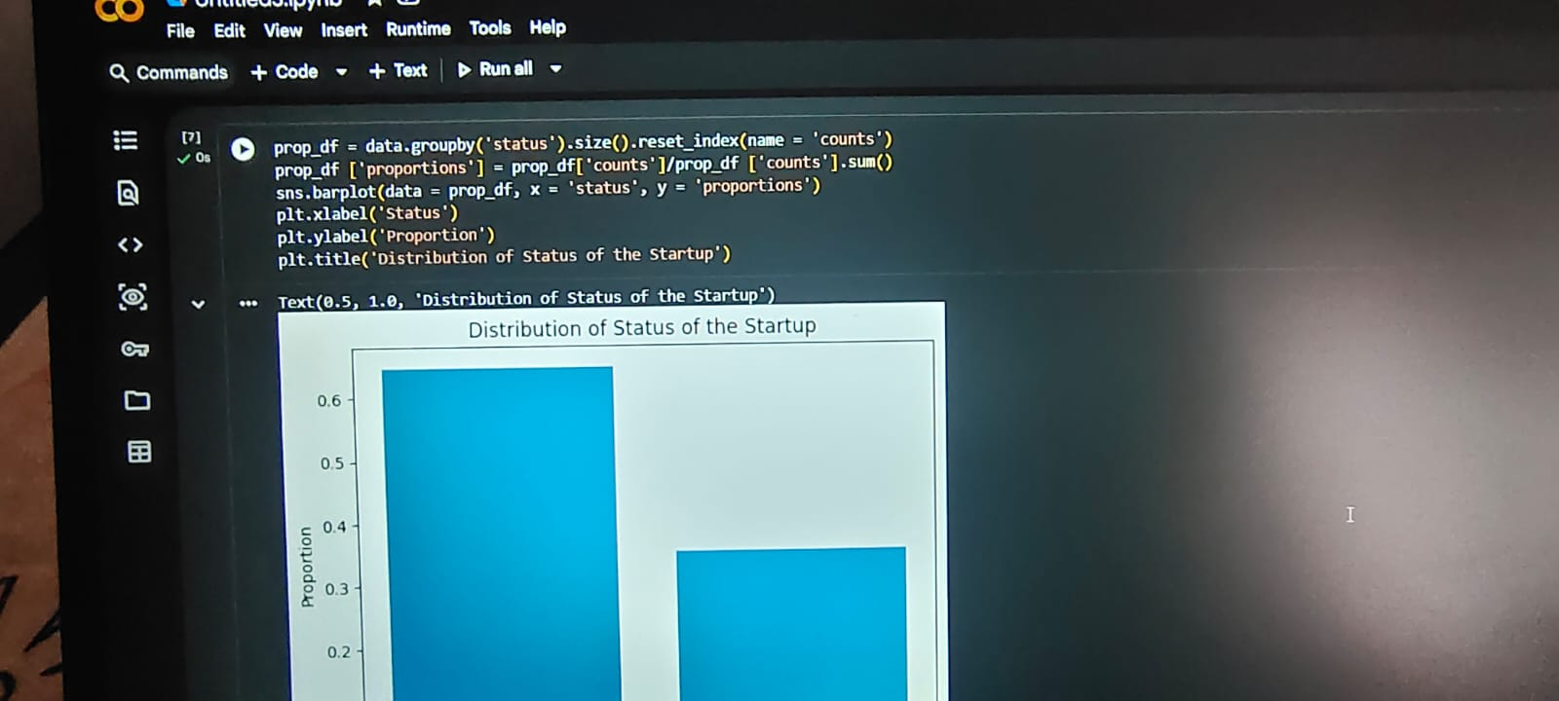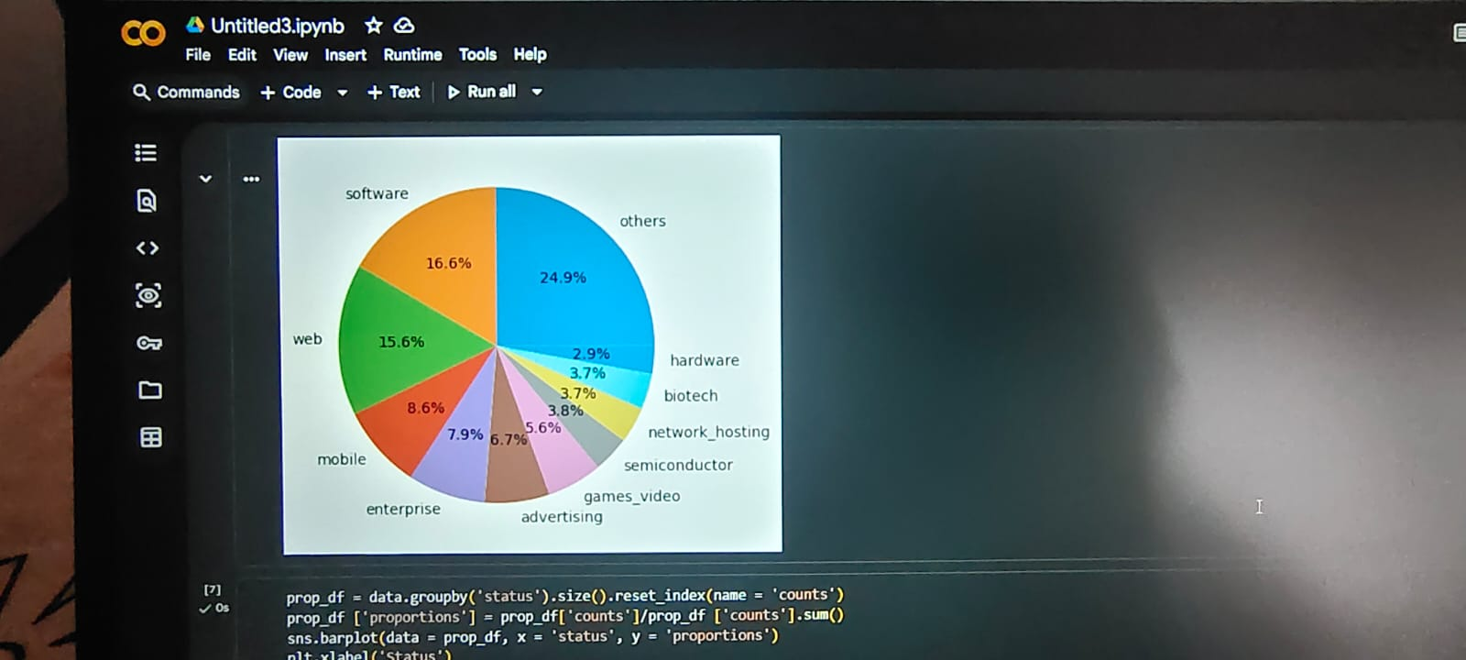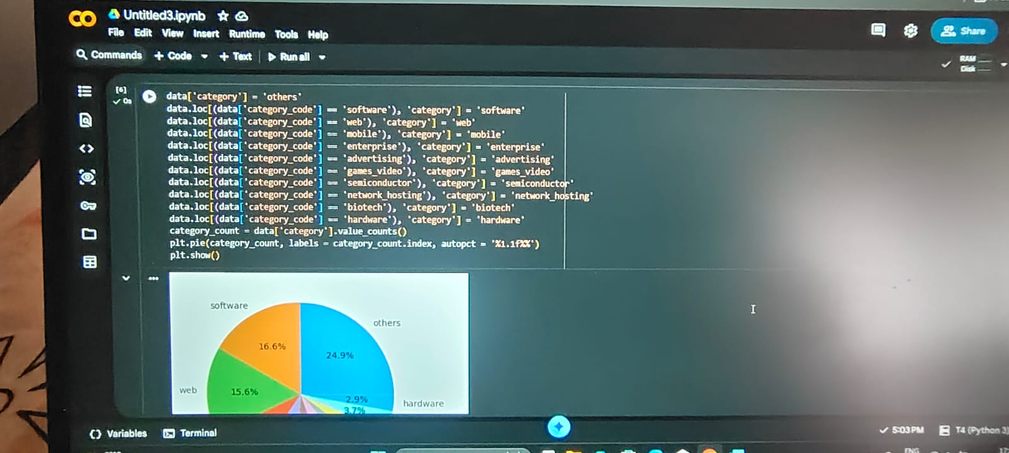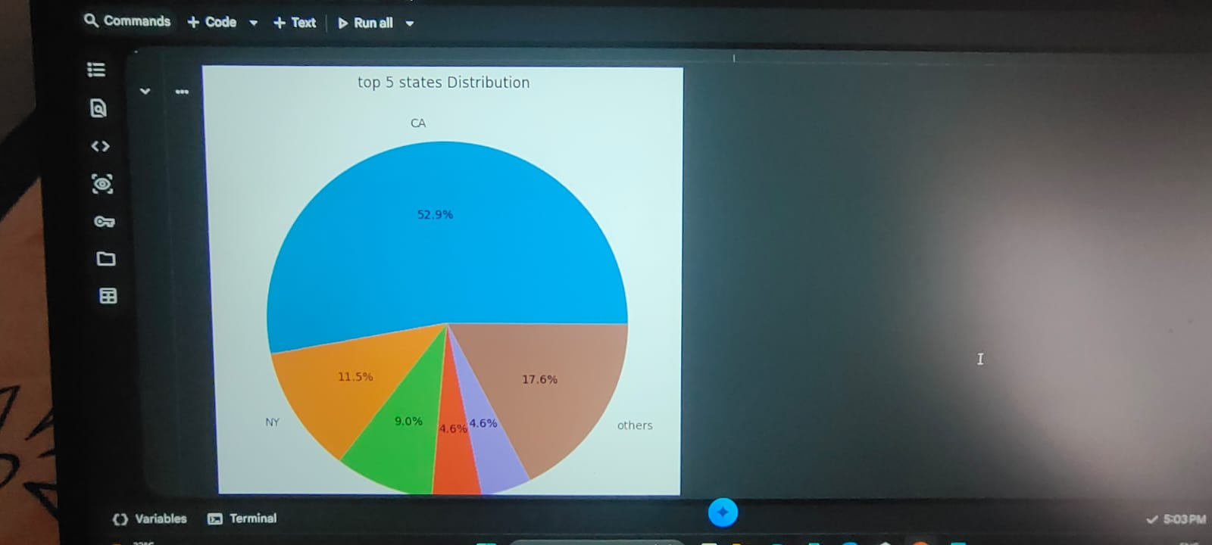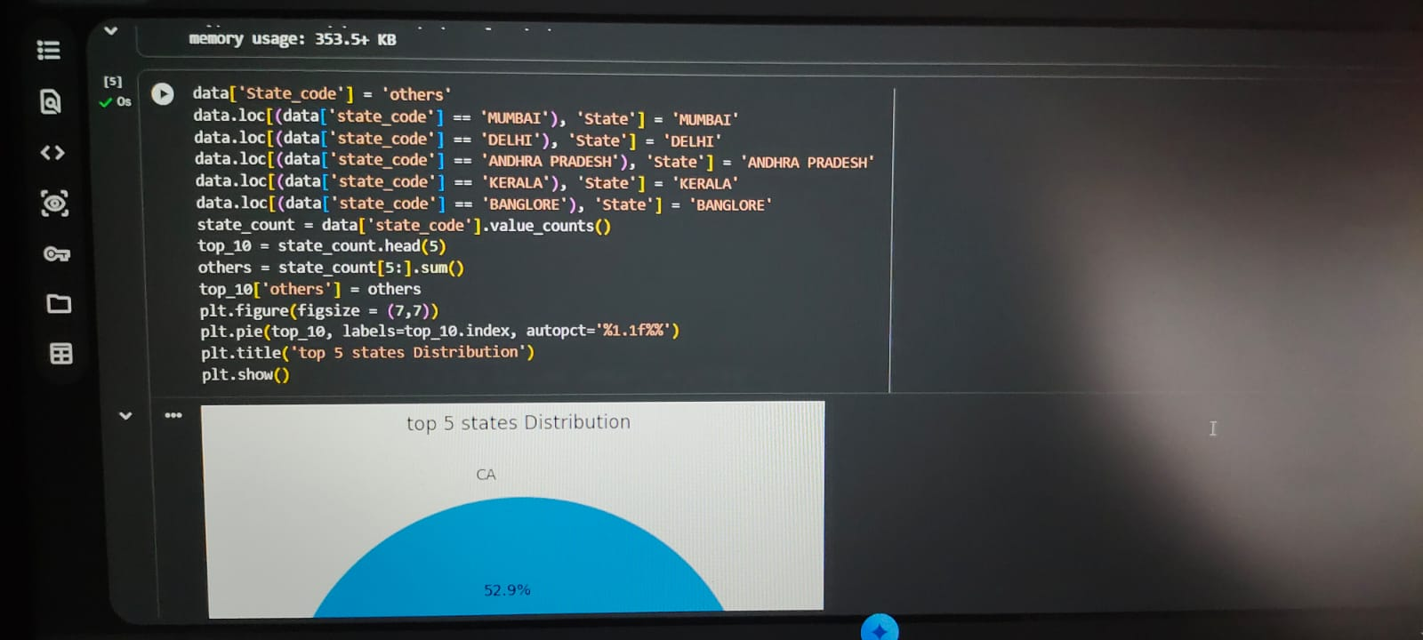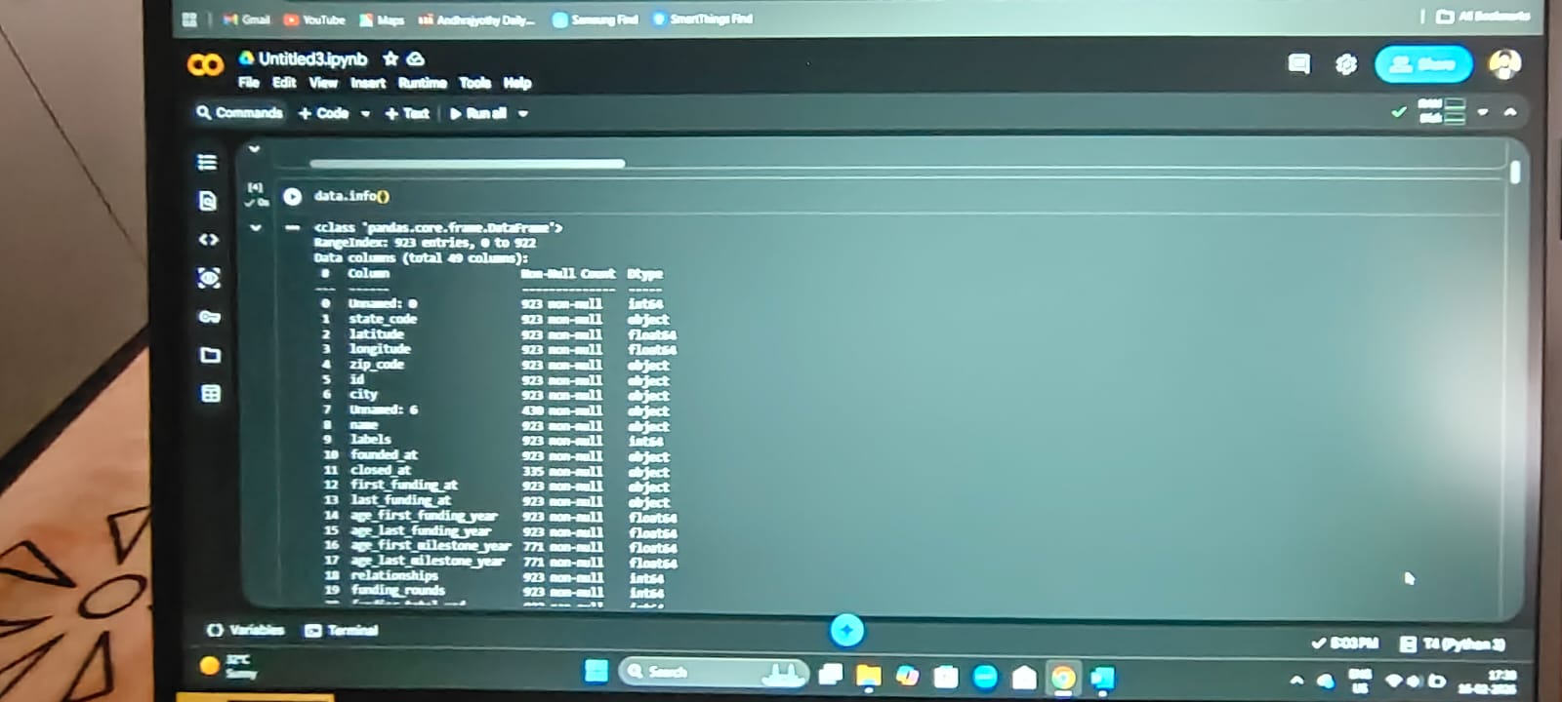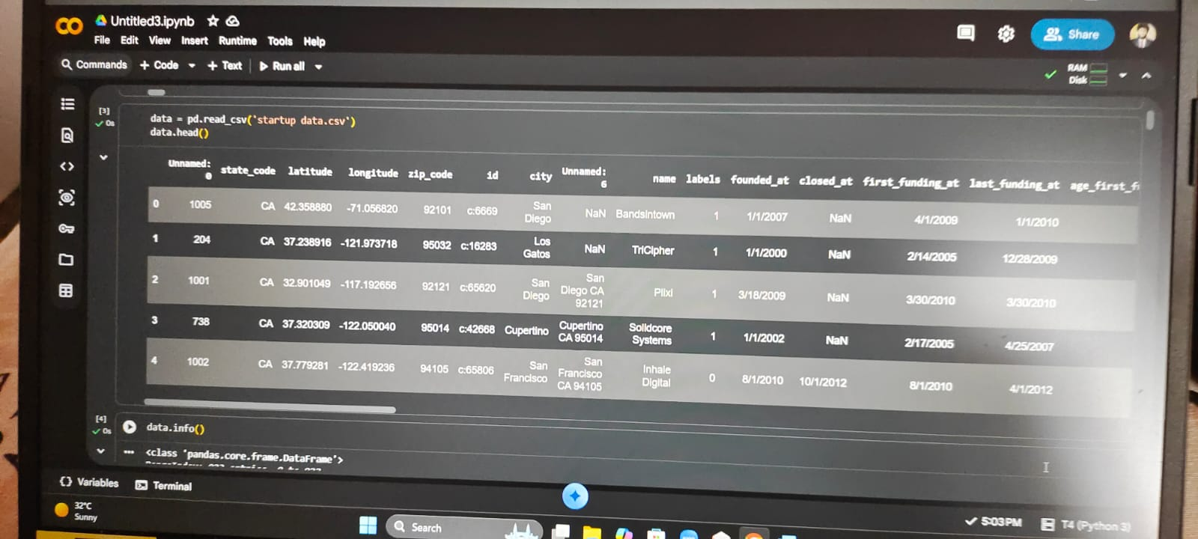

8. ADVANTAGES & DISADVANTAGES
8.1 Advantages
- Mitigation of Cognitive Bias: Humans are prone to "affinity bias" (investing in people like themselves) or "FOMO." AI provides a neutral, objective evaluation based purely on data patterns.
- Scalability & Speed: While a human analyst can vet a few dozen startups a week, an ML model can screen thousands of global ventures in seconds, identifying "hidden gems" in overlooked markets.
- Uncovering Non-Linear Patterns: AI can detect complex correlations that humans miss—such as the specific "timing" between a Series A round and a sudden spike in a competitor’s hiring.
- Real-Time Monitoring: Unlike a static pitch deck, ML models can provide a "Live Risk Score" that updates as news, social sentiment, or market conditions change.
- Cost-Efficient Due Diligence: By automating the initial screening, firms can reduce manual research time by up to 70%, allowing them to focus human expertise only on the highest-potential leads.

8.2 Disadvantages
- Data Sparsity (The "Early-Stage Gap"): Most early-stage startups have very little public data. Predicting success for a "two-person team with a laptop" is significantly harder and less accurate than for a Series B company.
- Look-Ahead Bias: Many models are accidentally trained on data that was only available after a startup succeeded (e.g., being "featured in the news"), leading to unrealistically high accuracy in labs that fails in the real world.
- The "Black Box" Problem: Sophisticated models (like Deep Learning) can be hard to interpret. An investor might see a "Low Success Score" but won't know if it's because of the founder's background or the market's volatility.
  - Correction: This is why we include SHAP/Explainable AI in our design.
- Sensitivity to "Black Swan" Events: Models are trained on historical data. They often fail to predict success during unprecedented shifts, such as global pandemics or sudden regulatory changes in 2026.
- Overfitting: A model might become too specialized in a specific industry (like FinTech) and fail to accurately predict success in a newer, emerging field like Quantum Computing or Biotech.

9. CONCLUSION
This project successfully bridges the gap between raw data and actionable venture intelligence. By integrating Ensemble Learning (XGBoost/Random Forest) with Explainable AI (SHAP), we have created a system that doesn't just predict if a startup will succeed, but explains why.
- For Investors: It serves as a bias-free "co-pilot" that flags high-risk indicators (e.g., high burn rates or team instability) early in the due diligence process.
- For Founders: It provides a data-driven mirror, allowing them to simulate different strategic paths and optimize their metrics for long-term viability.

10. Future Scope (2026 & Beyond)
As the startup ecosystem becomes more complex, the following enhancements will define the next generation of this project:
- Agentic Simulation: Moving from static predictions to "Agentic Workflows" where AI agents simulate a startup’s performance against various 2026 macroeconomic shocks (e.g., sudden shifts in interest rates or regulatory changes).
- Multimodal Sentiment Analysis: Incorporating video and audio analysis of founder pitches to detect subtle indicators of resilience, confidence, and leadership "grit"—factors often missed by financial data alone.
- Real-Time "Drift" Detection: Implementing automated pipelines that retrain the model as market "moats" shift from traditional software to specialized AI applications and decentralized infrastructure.

11. APPENDIX
Dataset Link: https://www.kaggle.com/datasets/manishkc06/startup-success-prediction OR
C:\Users\BANDI NAGA PAVAN\Downloads\archive\startup data.csv
GitHub – pavan757/Machine-learning-for-startup-success-predictor
Project Demo Link: VIDEO DEMO LINK IN PROJECT DEMONSTRATION FOLDER
Google colab notebook link:
https://colab.research.google.com/drive/1BNZez-eXhjafo5mvjwAVzDosEVcV9a0c

(note: first restart and rerun all cells, for the dataset we have to downloaded in excel format from Kaggle & save in pc after, that will be uploaded in browse files, after all visualizations , pre- processing and model deployment code will take 5 minutes for execution, after run all in last cell streamlit web application will show
By clicking that we can access web link and some errors are coming while prediction , sorry for that I don’t know how to do that )

Streamlit web link: https://unjarred-rae-glaucously.ngrok-free.dev
(Note: this link will work only when session is actively running or when the session is restart and rerun all cells ).

